Why extend RuntimeException?
Because:
- It’s unchecked
- Business exceptions are usually unchecked
- Cleaner service layer
Interview tip:
“Business exceptions should usually be unchecked.”
Java Checked vs Unchecked Exceptions:
- Checked Exception: These exceptions are checked at compile time, forcing the programmer to handle them explicitly.
- try-catch block and declared the exception in the method signature using the throws keyword.

- 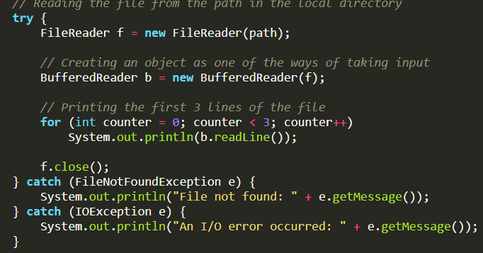
- Derived from Exception.
- Caused by external factors like file I/O and database connection cause the checked Exception.

- Unchecked Exception: These exceptions are checked at runtime and do not require explicit handling at compile time.
- Unchecked exceptions are runtime exceptions that are not required to be caught or declared in a throws clause.
- These exceptions are caused by programming errors, such as attempting to access an index out of bounds in an array or attempting to divide by zero.
- Unchecked exceptions include all subclasses of the RuntimeException class, as well as the Error class and its subclasses.
- Derived from RuntimeException.
- Caused by programming bugs like logical errors cause unchecked Exceptions.

